A chilling afternoon at Starbucks

(the first ever Starbucks coffee shop in the world)

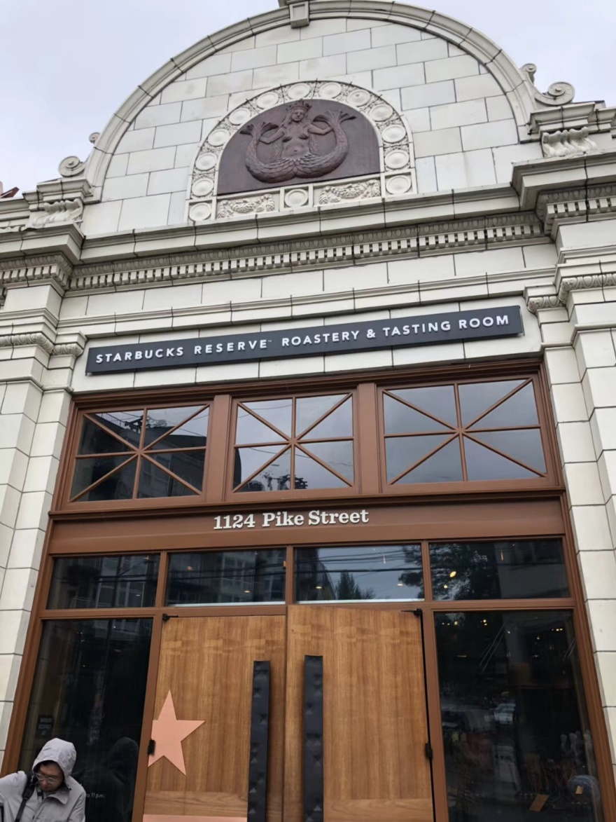

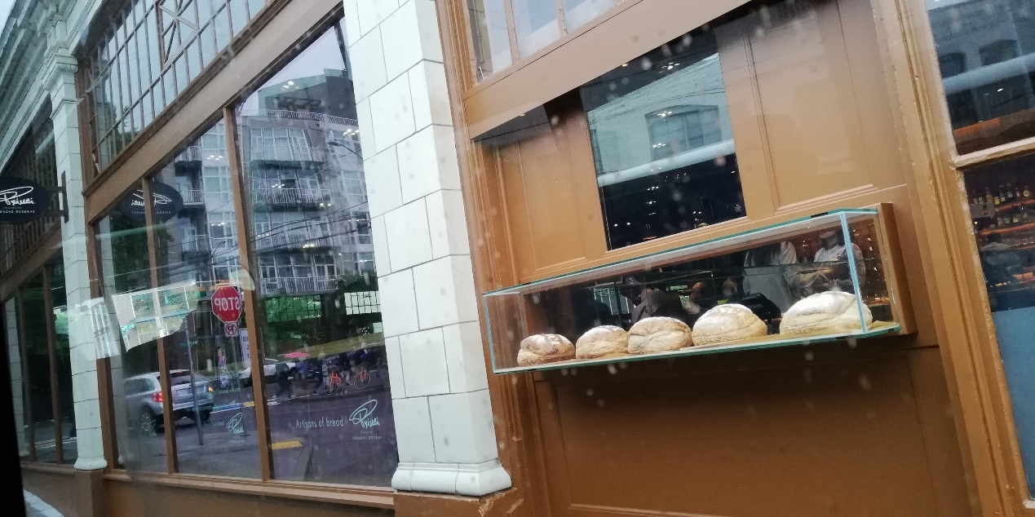



Once we entered inside, the first thing greeted we was the gorgeous smell of freshly-made coffee. The scent of coffee bean just has the magic power that calms you down instantly no matter what kind of hurry you’re in. Not like any of the Starbucks that I’d been to before, the place was extraordinarily spacious and glamorous. You can buy all kinds of souvenirs such as the delicate mugs, post-cards, bottles and the list go on in the shopping area; you also can enjoy the delicious desserts in the canteen over the other side. If you are curious about how these raw coffee beans are processed and made into the coffee in your cup, then you’ve come to the right place. Behind the counter, there are pipes, large cans, and loads of other instrument that are used to transport, heat up and storage these coffee beans. The whole process is presented clearly right in front of you. A guide there explained us the process in details and walked us through the history of Starbucks while we were served with hot, freshly-made, high-quality coffee at the table. What a nice cup of coffee! What a beautiful and fruitful afternoon!

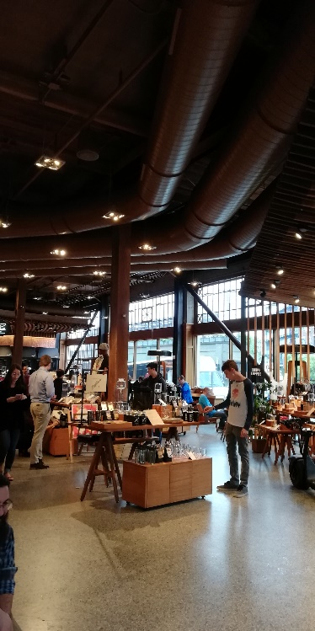 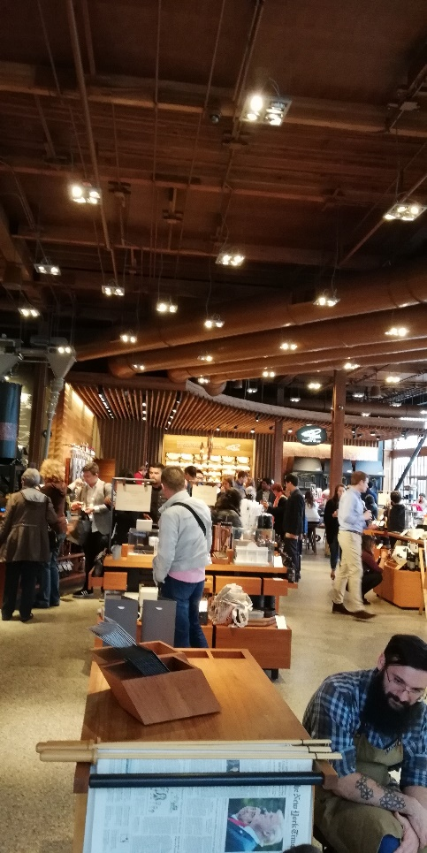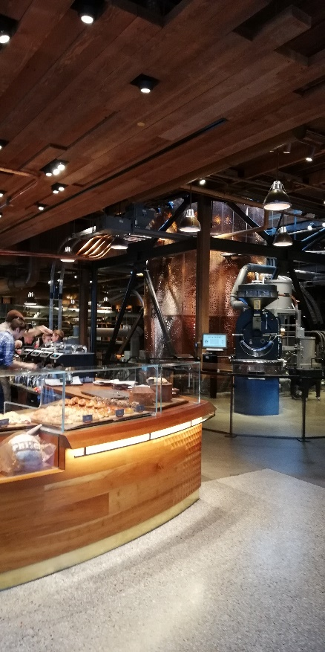 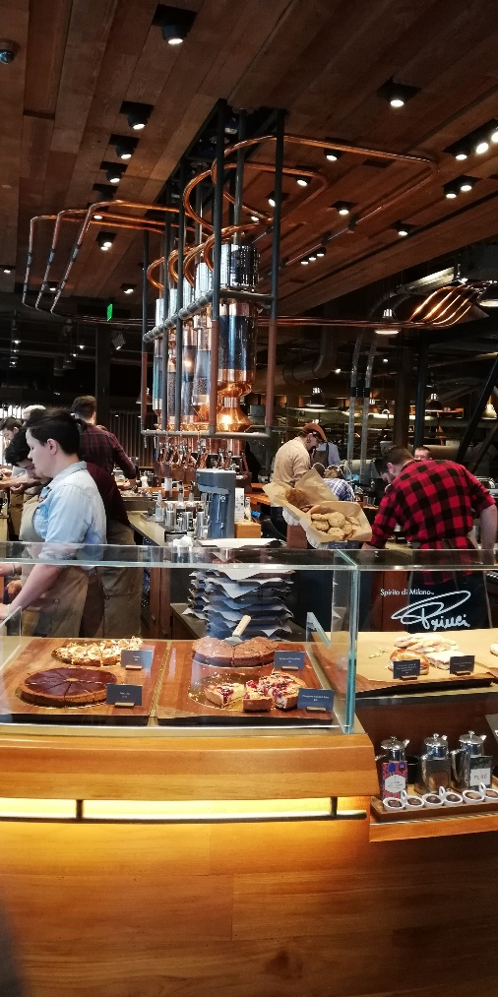

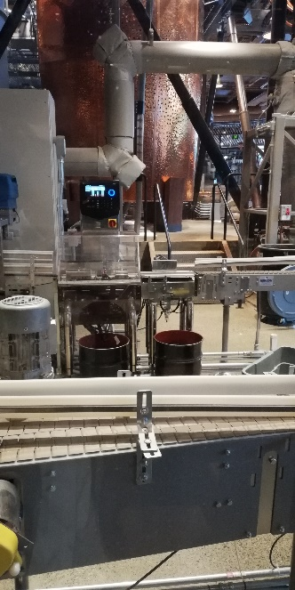 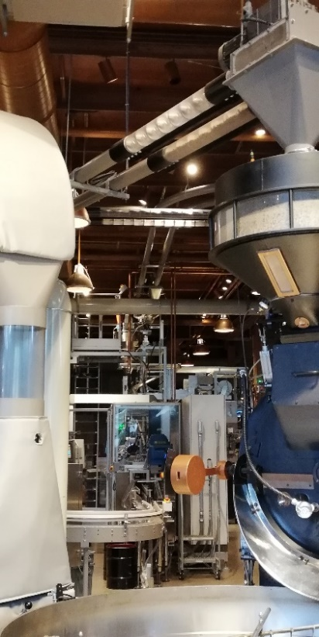 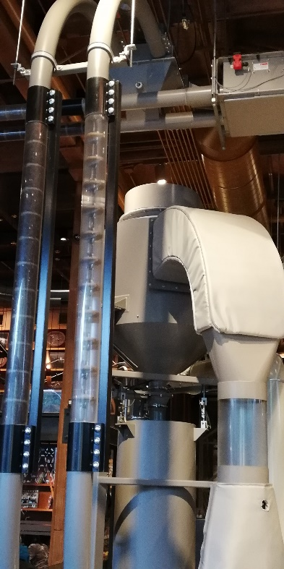

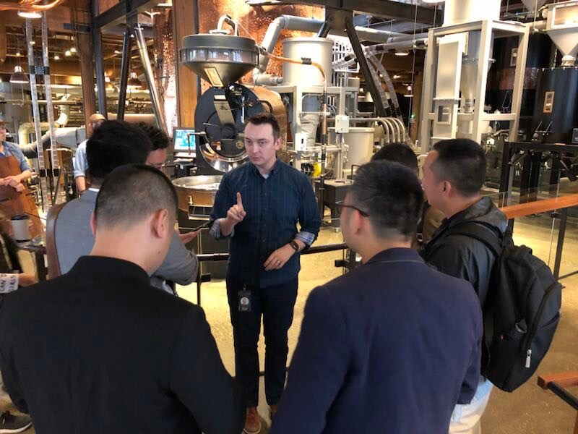

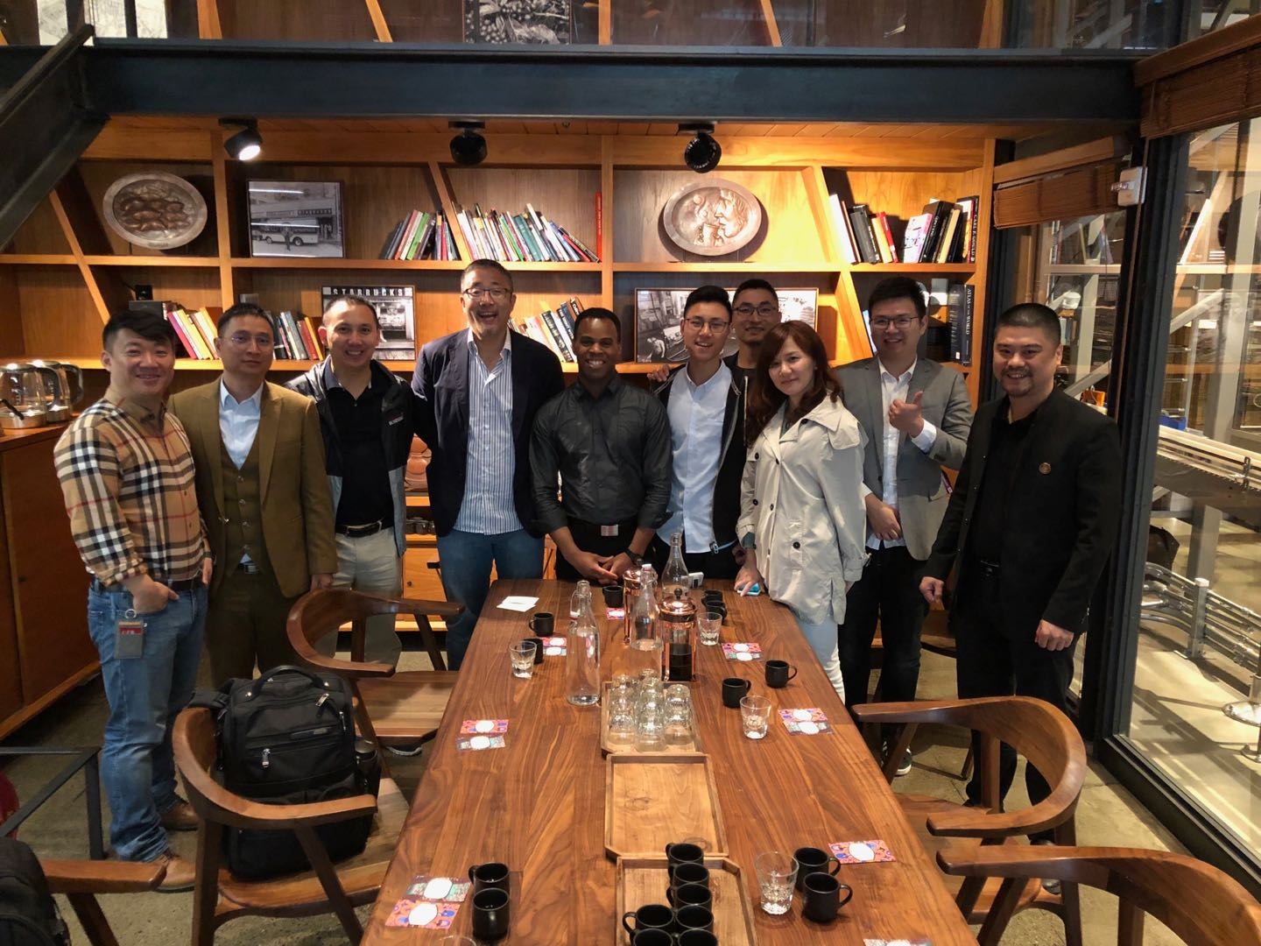

A great tea party！

**Boeing**

(Day 7)

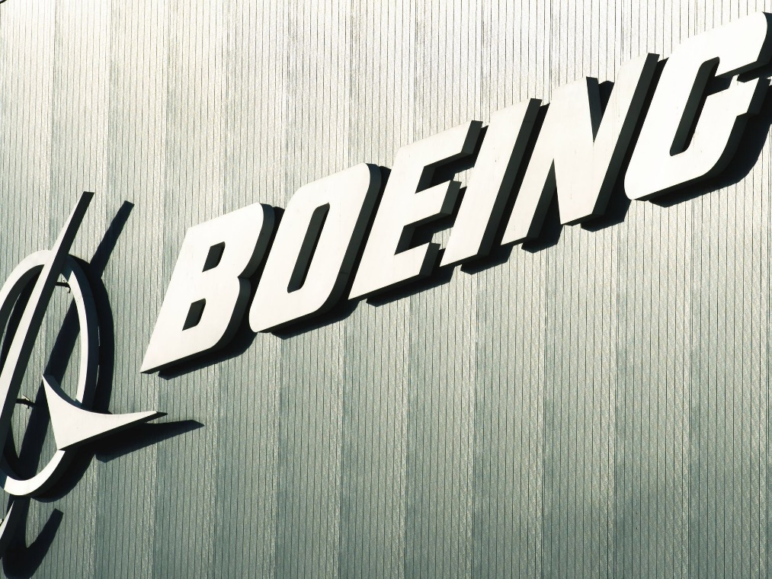

**Basic introduction of Boeing:**

**The Boeing Company** ([/ˈboʊ.ɪŋ/](https://en.wikipedia.org/wiki/Help:IPA/English)) is an American [multinational corporation](https://en.wikipedia.org/wiki/Multinational_corporation) that designs, manufactures, and sells [airplanes](https://en.wikipedia.org/wiki/Airplane), [rotorcraft](https://en.wikipedia.org/wiki/Rotorcraft), [rockets](https://en.wikipedia.org/wiki/Rocket), [satellites](https://en.wikipedia.org/wiki/Satellite), and [missiles](https://en.wikipedia.org/wiki/Missile) worldwide. The company also provides leasing and product support services. Boeing is among the largest global [aircraft manufacturers](https://en.wikipedia.org/wiki/Aerospace_manufacturer); it is the second-largest [defense contractor](https://en.wikipedia.org/wiki/Defense_contractor) in the world based on 2015 revenue,[[5]](https://en.wikipedia.org/wiki/Boeing#cite_note-DefenseNews_Top_100-5) and is the largest exporter in the United States by dollar value.[[6]](https://en.wikipedia.org/wiki/Boeing#cite_note-6)[[7]](https://en.wikipedia.org/wiki/Boeing#cite_note-Boeing_about-7) Boeing stock is included in the [Dow Jones Industrial Average](https://en.wikipedia.org/wiki/Dow_Jones_Industrial_Average). (source: from http://www.iciba.com/introduction)

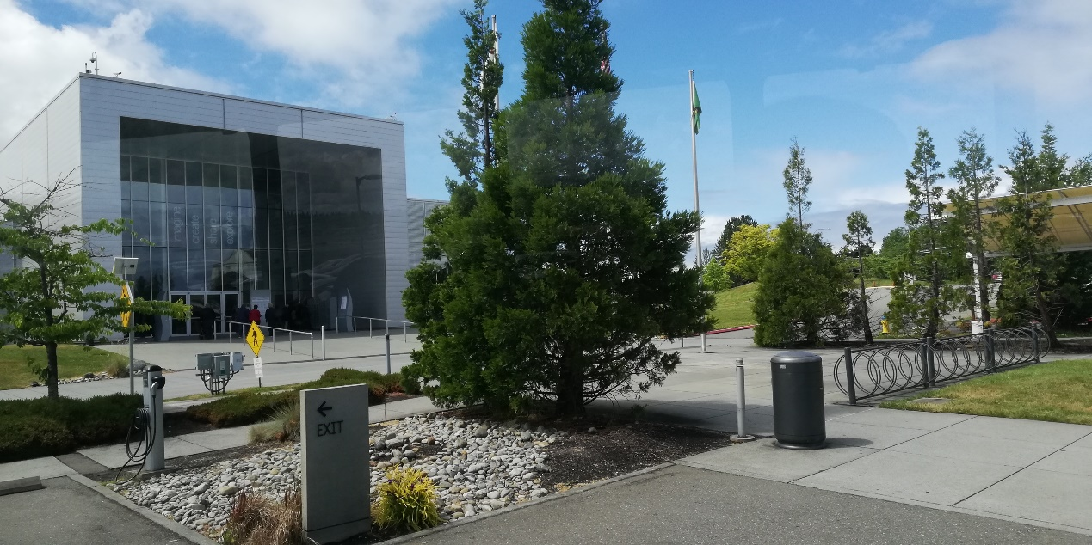

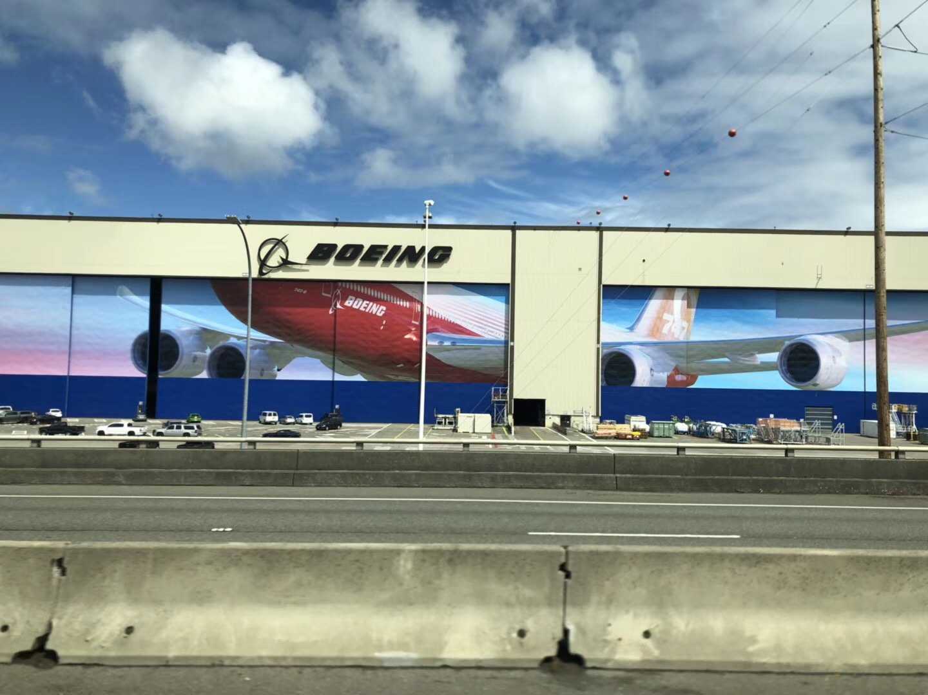

The largest mural painting in the world at present

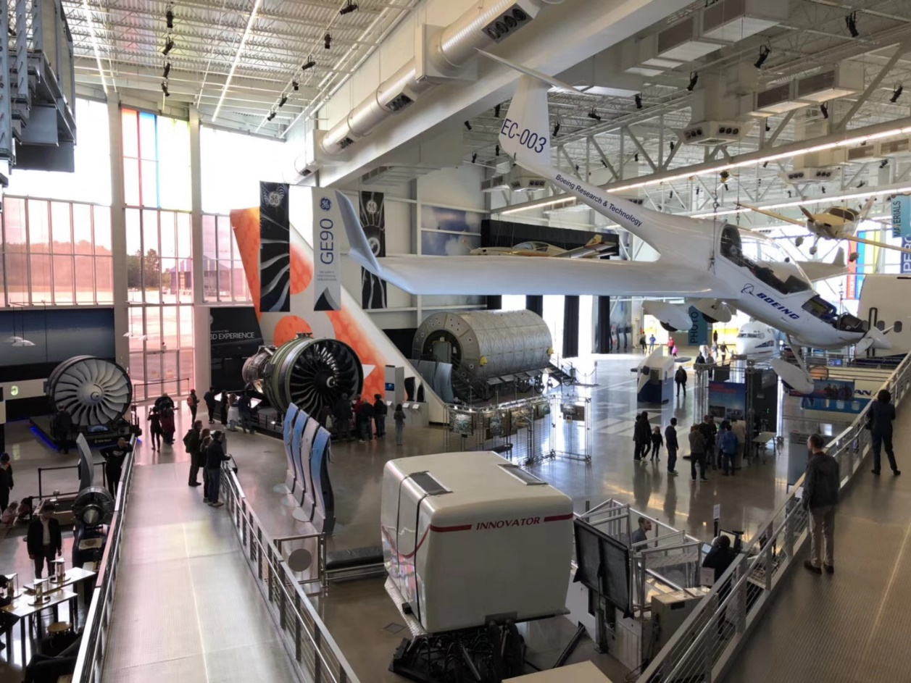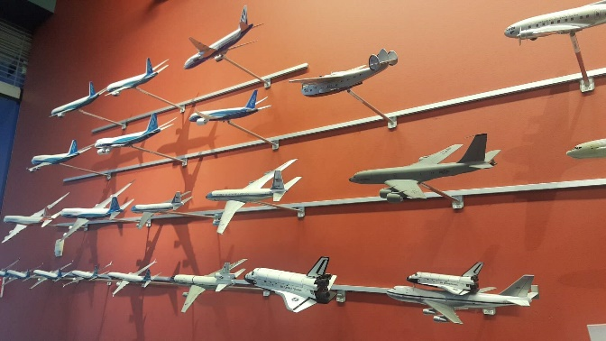 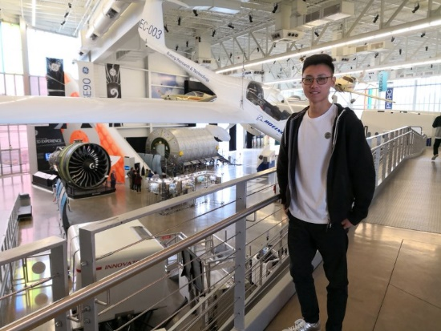

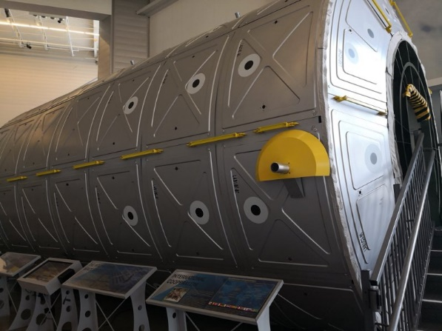 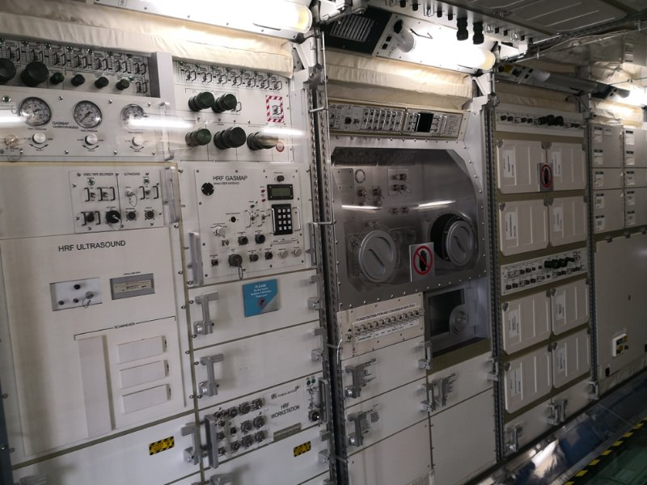

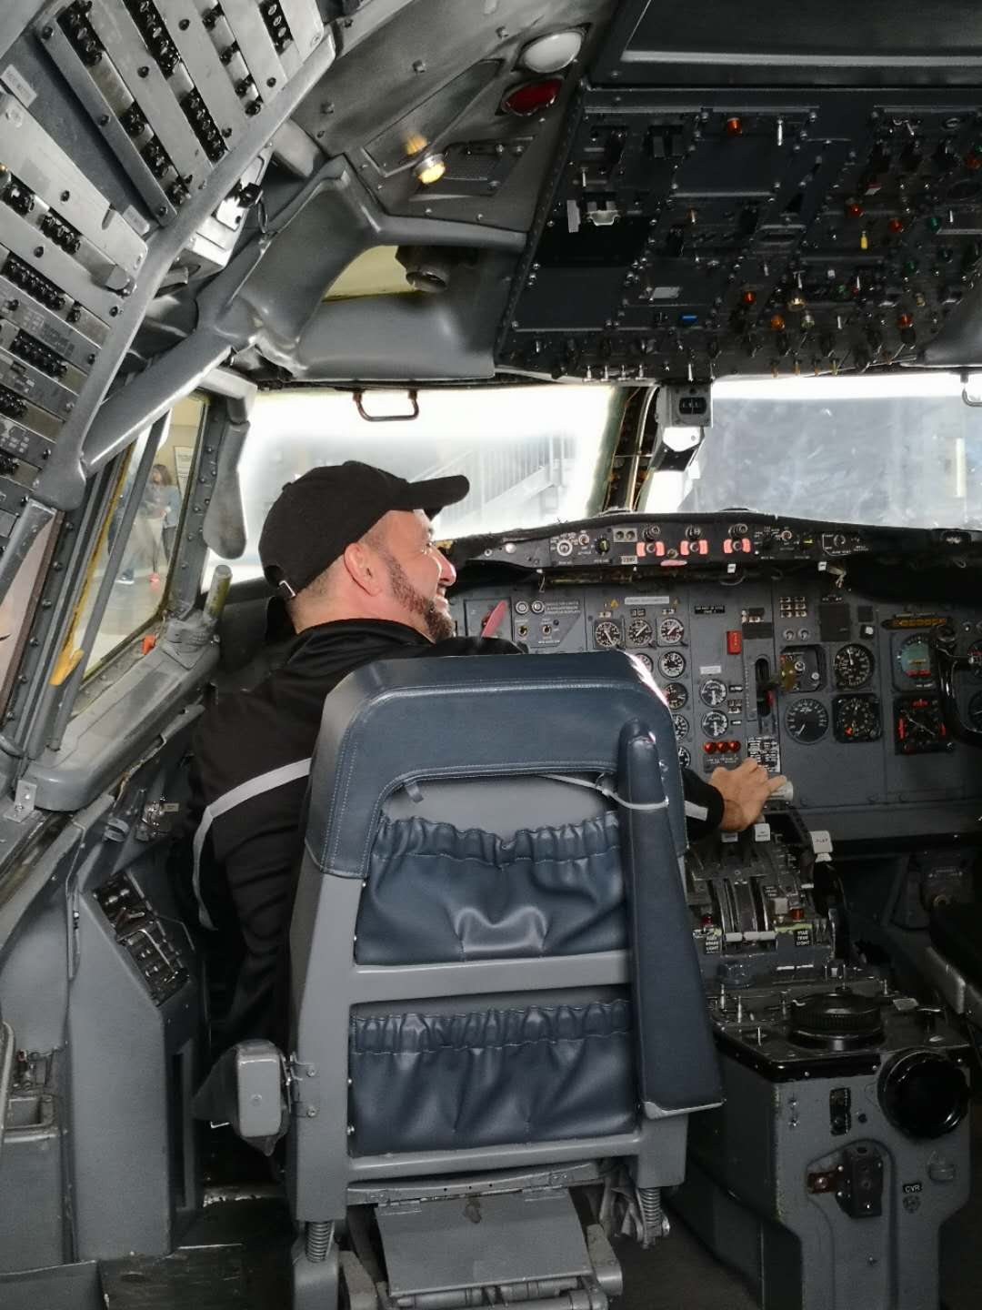

These are all the pictures taken at the Boeing Visitor Center. Unfortunately, due to the company’s privacy policy, we weren’t allowed to take any pictures when we were inside the air plane manufacturing factory. But here, I just want to say that the air plane manufacturing factory of Boeing is definitely one of the most advanced and impressive factories on the face of this planet.

Their factory is totally automated and the whole space of the air plane manufacturing workshop is fully utilized. For instance, this corner is for the process of body, another is for the production of wings, and all these parts will be removed to the center and to be assembled there. You also can see there are lines of different colors marked on the floor which provide workers with the direction and help them to organize assemblies. During the whole process of production, machines do most of the work, and there is only a little human intervention. In comparison, in most of the manufactures in China, what you see is that people are stressed out, working desperately there, lots of space in the factory is wasted, everything is in a mass. Take my dad’s factory for example, it takes nearly 20 people’s labour force to produce one security door even with the help of advanced manufacturing equipment, whereas, for Boeing air plane manufacturing factory, it only takes five to six people’s labour force to manufacture a large air-plane. This is the power of technology!

Seattle downtown trip

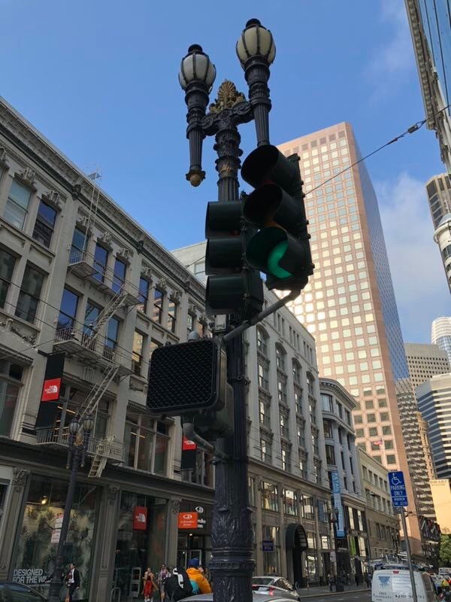 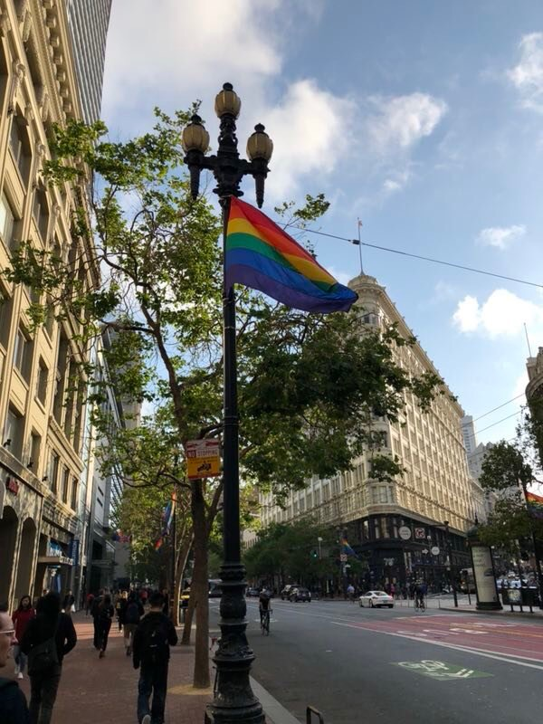

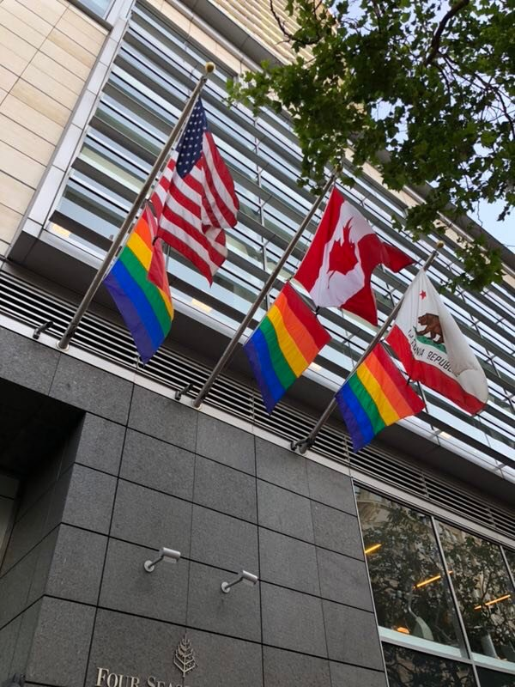

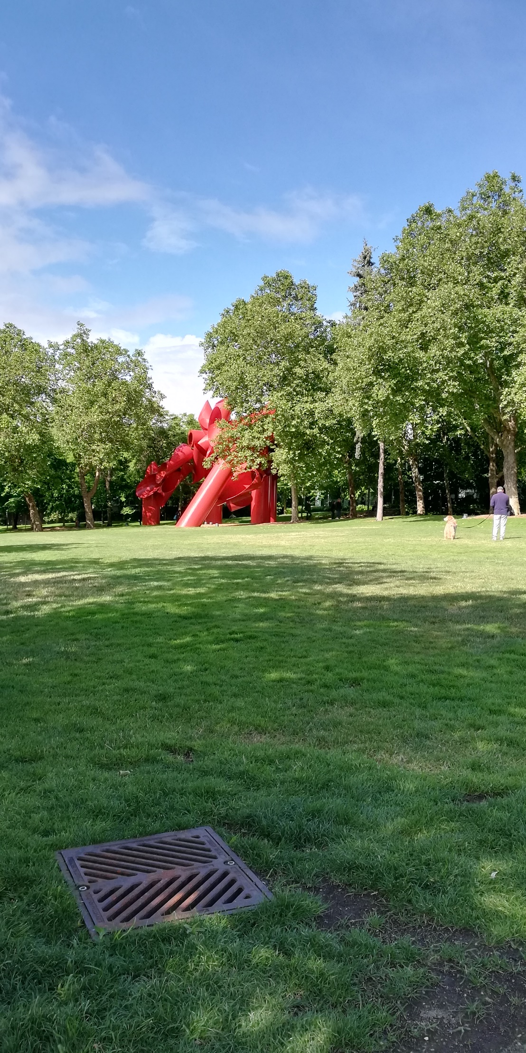

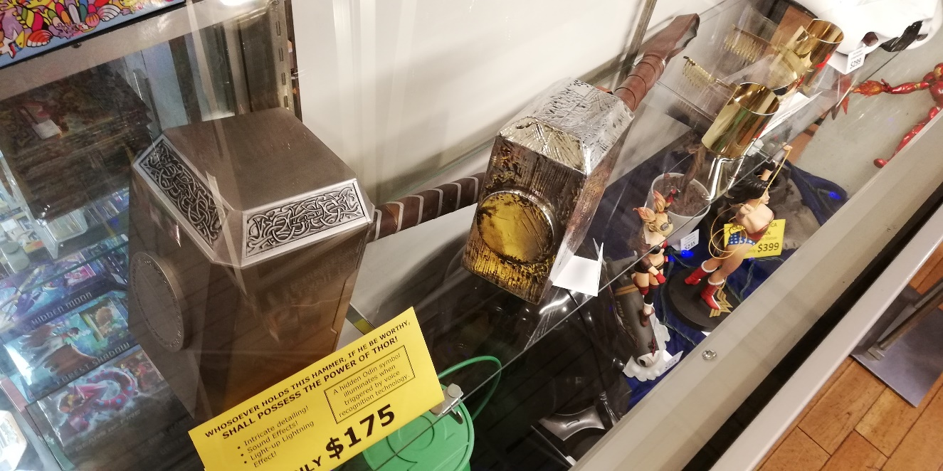

The spectacular Space Needle!

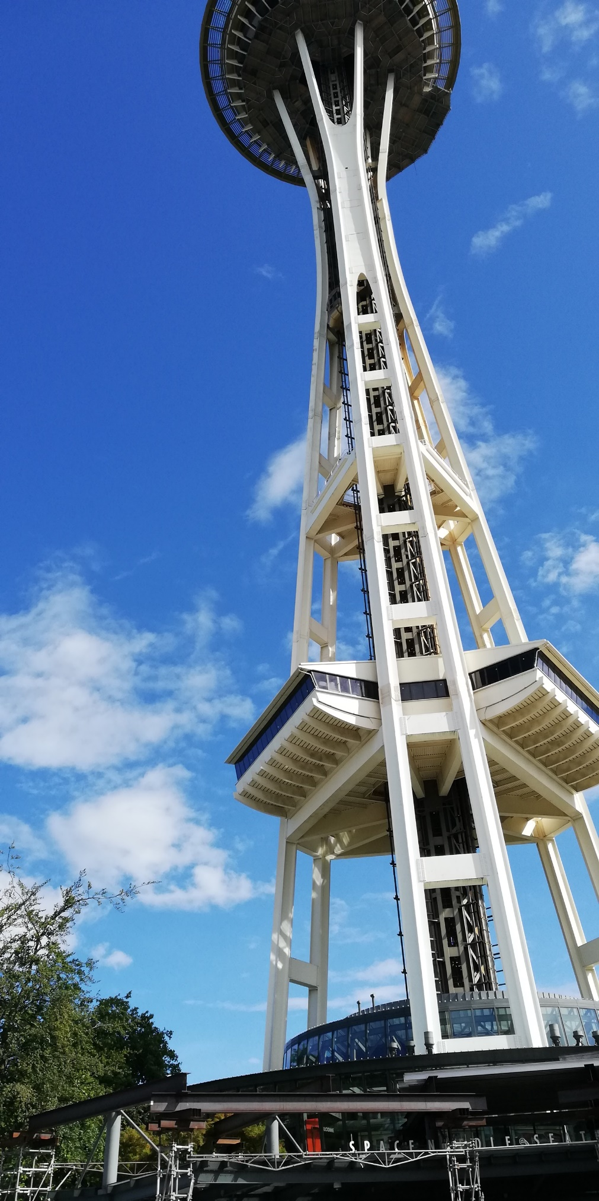

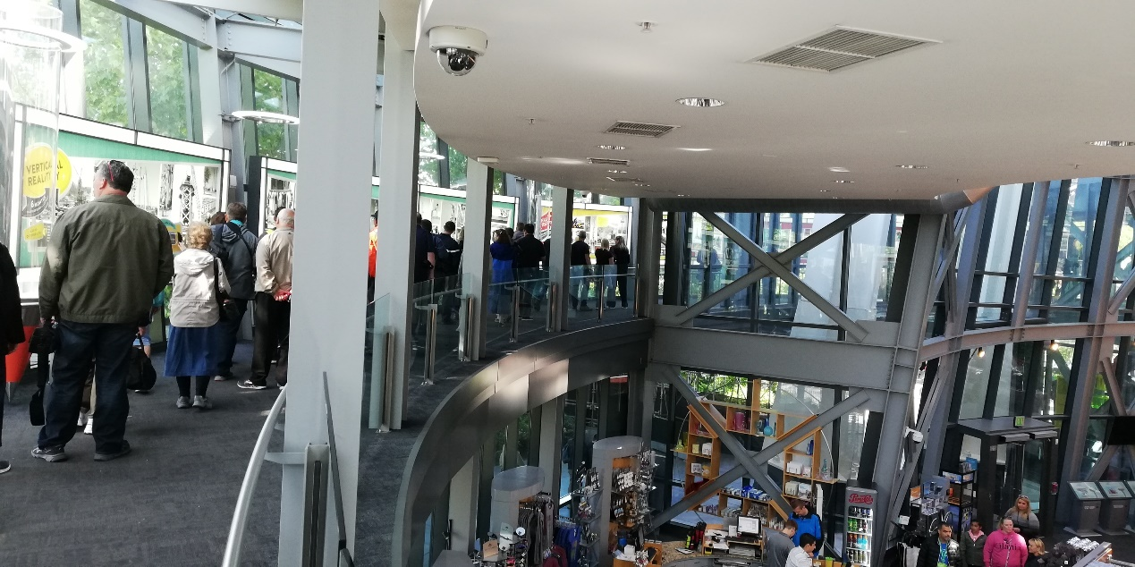

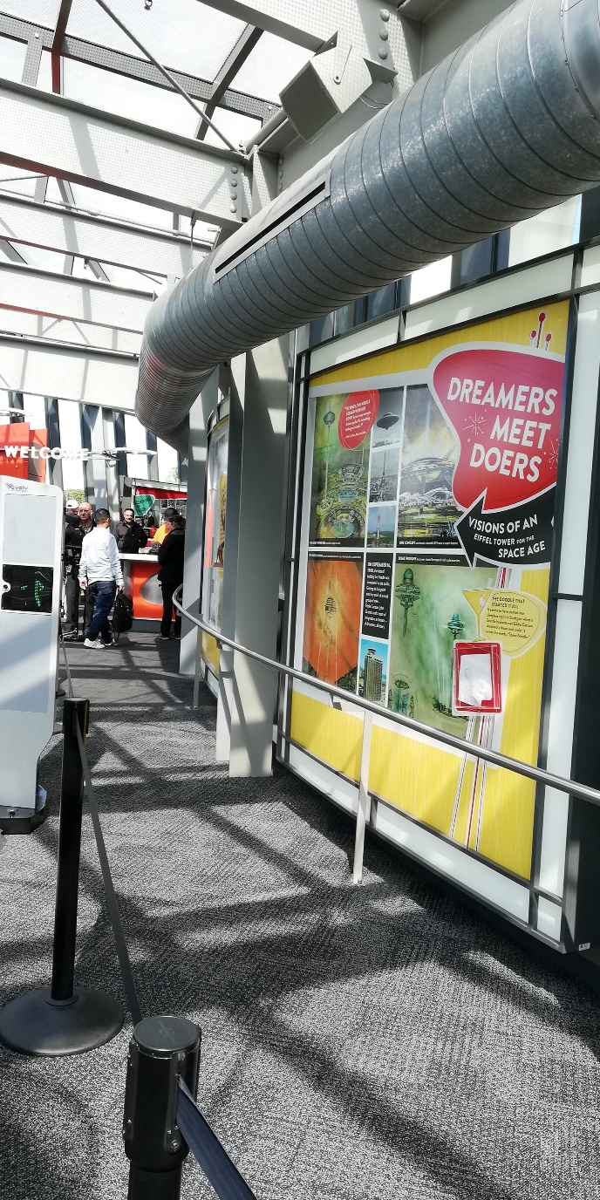

~ Sky view: overlook the whole city ~

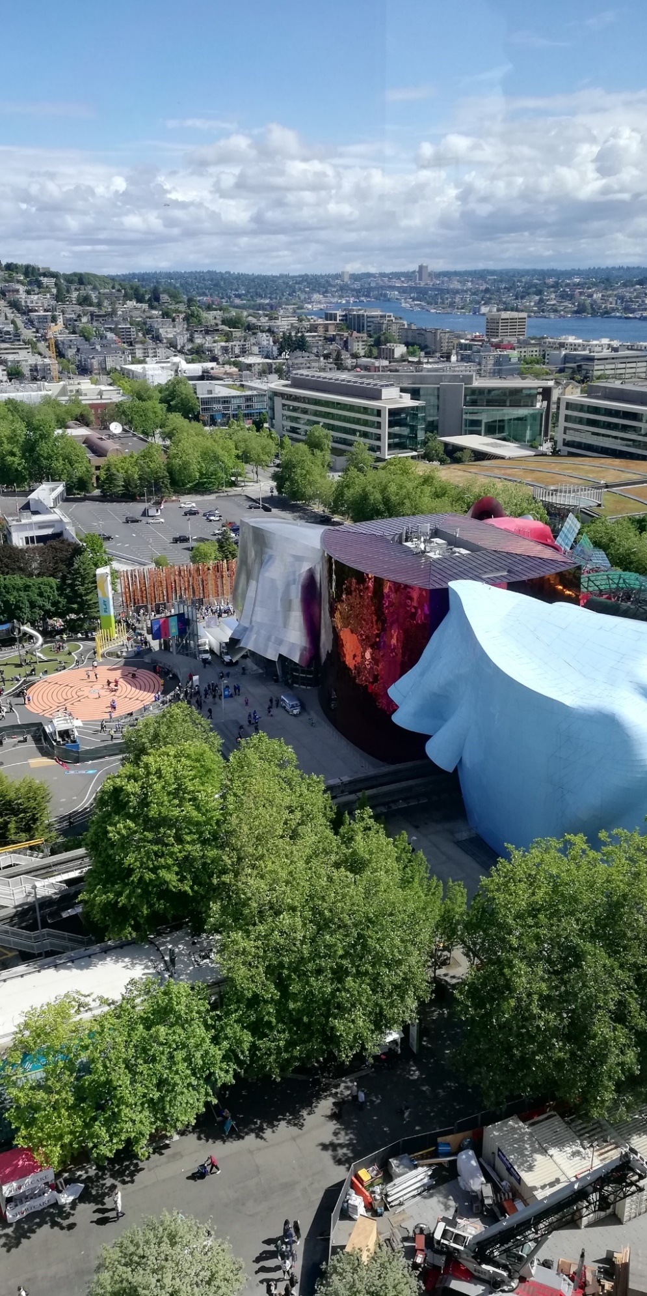

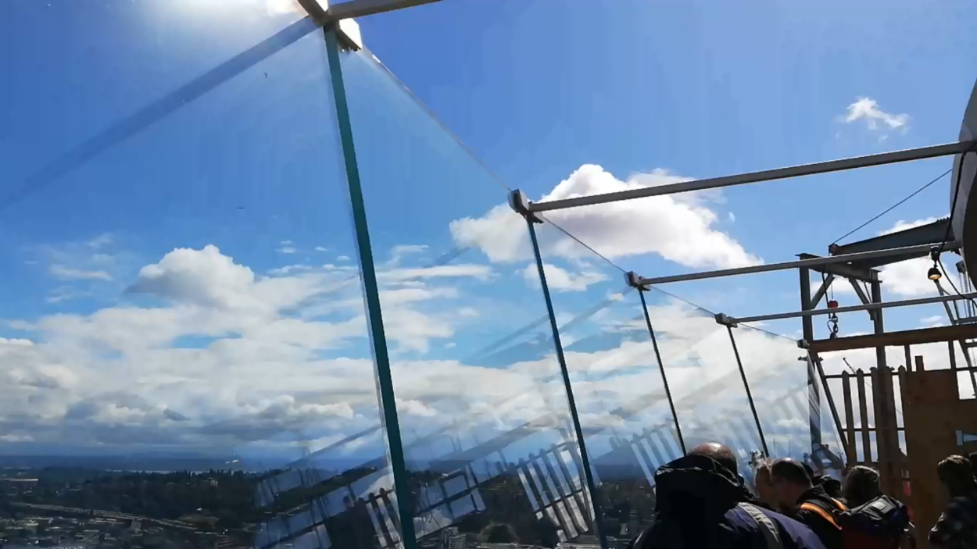

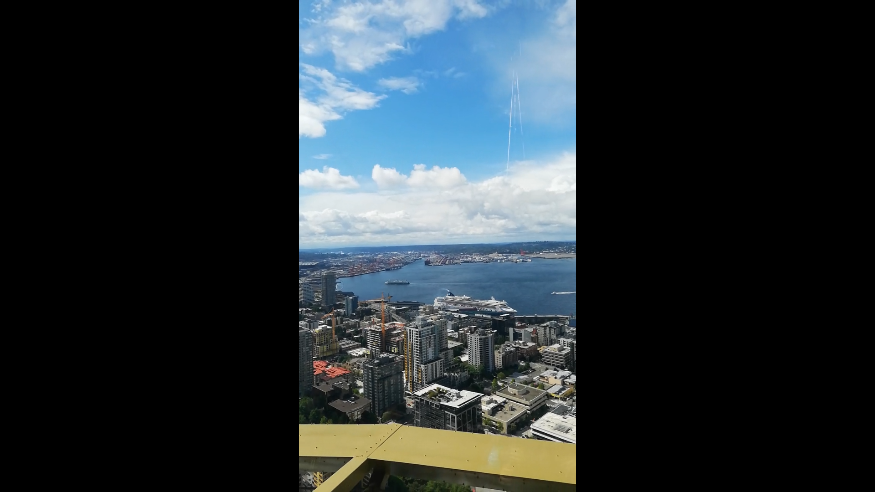 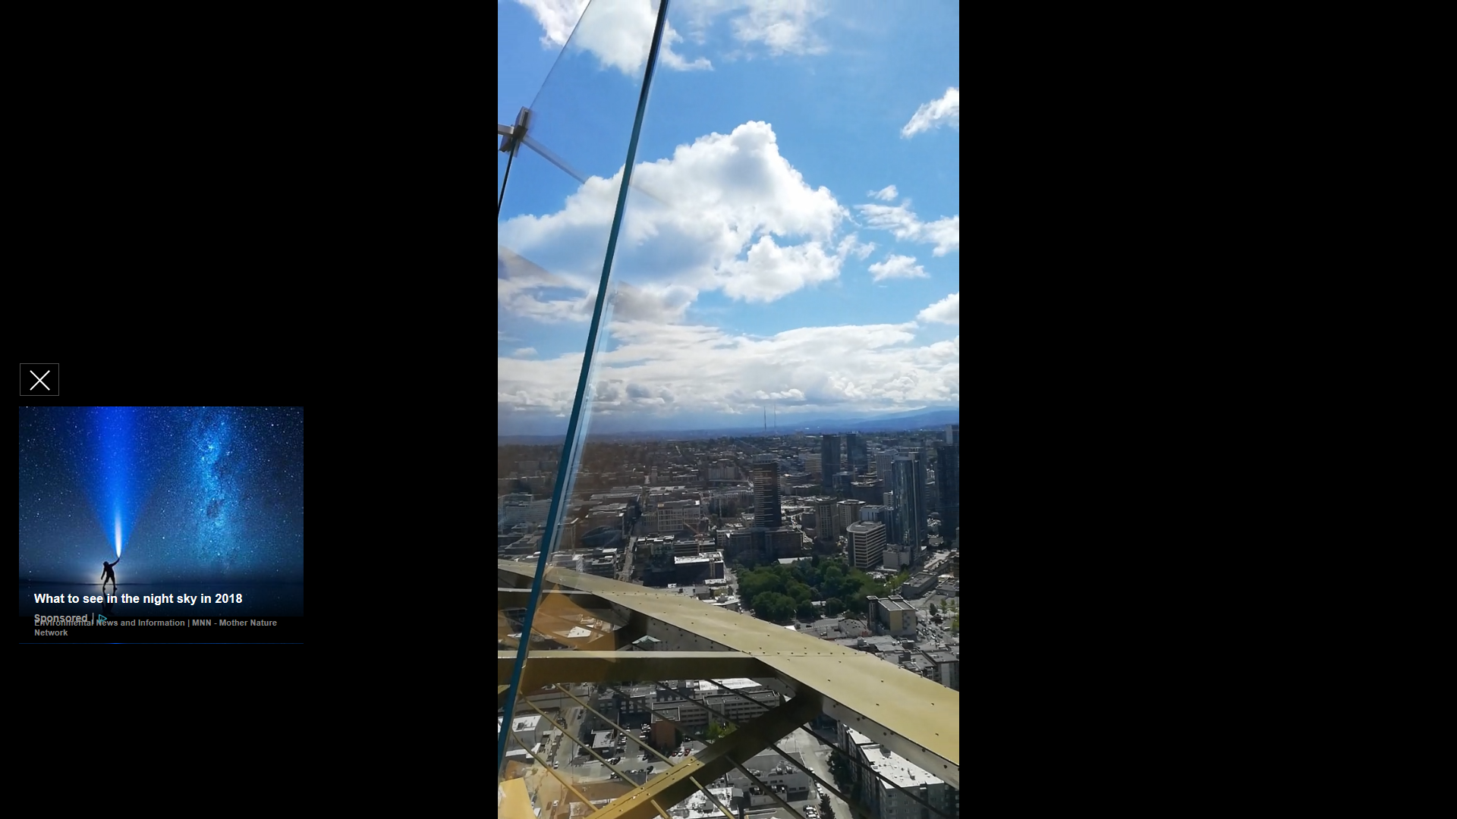

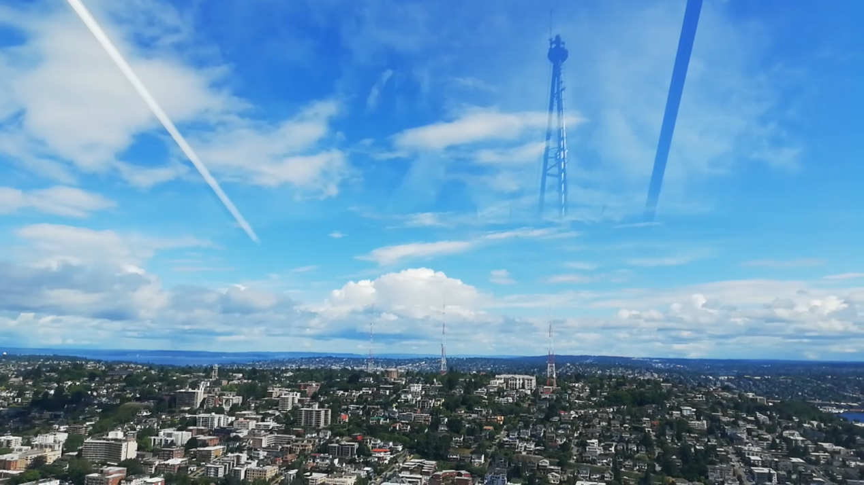

. . . More to be continued

in the future (maybe tomorrow; maybe the next second; maybe …)

Silicon Valley mentality: You learn by doing.

Ending:

previously, my dad who attends the “*Strategic Innovation & Design Thinking*” class for entrepreneurs like himself at our local university came to me one day and asked me that if I was interested in such a twelve-day *Strategic Innovation & Design Thinking* tour to America. I had never heard of “Design & Innovation” such concept before and the only thing I knew was that it’s definitely for entrepreneurs that I was not. I asked him for more details but he was not given any more information on the trip until next week and the decision needed to be made by the end of this week. Anyway, I decided to give it a try, after all, I had never been to America and it’s not a bad thing to take a break from my regular busy studying schedule. Never had I expected that we were going to visit so many great companies in Silicon Valley nor to actually attend classes at Stanford. It turned out to be one of the trips I liked most and had so much impact on me, let me know more about Silicon Valley and Stanford, help me find out where my passion lies in. Without take this chance, I wouldn’t have so many stories share with you about it and I’m glad that I made a good choice and I’ll always give it a try no matter how things may end.

-What is “*Strategic Innovation & Design Thinking*” in my understanding?

Design & Innovation is not just a tool for business, it is more about a way of thinking. In fact, Design & Innovation is everywhere in our life. For our three daily meals, we can think about how to design a better dining experience from several dimensions such as convenience, health and taste. For our daily commutes, again, we can we can think about how to design and innovate a new transportation from dimensions such as safety, comfort, convenience, etc. There are even more opportunities for business innovation either in terms of products or services. For most of the time, what we really lack is not the capital for development nor the instant inspiration for innovation, but a curious and insightful heart, and the willingness to act and to change the present situation. It doesn’t matter which industry you work in, where you are, if you have such mentality that “if I see the world that we currently live in as a prototype, how would I design it to make it a better place for human to live?” then you definitely can innovate things that people truly want. If you want to change everything, start from changing yourself first. Let Design & Innovation become you, and let yourself become the next world-class business elite!

Why “*Strategic Innovation & Design Thinking*” captivates me so much?

-Design Thinking

I was very curious about the how all technological miracles happen in Silicon Valley? what makes Silicon Valley the hometown of innovation? What kind of concept or mentality do people have that gives them the inspiration of innovation. What strategies or methods do these tech-innovative companies use when they innovate their products, services or even business?

To learn more about it, I read lots of books including creative confidence, ... and there are also some online resources such as playbook for ..., IDEO’s Human-Centered Design Toolkit, d.school website... in this learning process, I did notice some positive changes in myself like before, I only knew that the only way to guarantee a bright future is to get into a good college, successful graduate from it with a diploma, find a safe and decent job, live a comfortable life. That’s what most people in China encourage their children to do. Now I’ve learnt you can ether live a life that is designed by others or live a wonderful and meaningful life designed by yourself. I believe that everyone has their unique creative power, but most of them just give up their dreams, afraid to pursue what they are passionate about, instead, they choose to listen to what other people say. Steve Jobs, Bill Gates, Elon Mask and many other successful individuals, they know what they want in their life and they choose to be the designer of their life. Here is one of my favorite quotes from the book Creative Confidence “What was I put on Earth to do?” So, I constantly ask myself: before I leave this world, what legacies do I want to leave to the world? Through this journey (Silicon Valley & Stanford trip), I got to know more about the technological innovation and the power of computing in this day and age, I now know what I want in my life. I want to become someone who can fully utilize the power of technology to make big impact on the world. And I don’t just say it. I do it! I do believe in the magic power of technology.